Data Link Layer; class 3

17.09.2018

*Diapo : Data link layer NKO*

### 1/ In general

In transport Layer :

Ip address of machine

App id : Application name to which the data is supposed to be directed or where it’s from

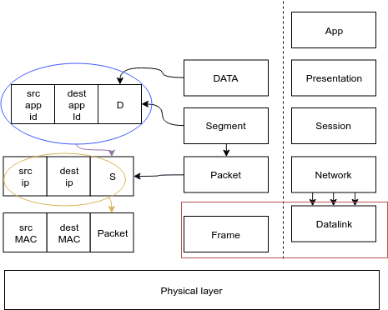

Today : Data link Layer

It creates a frame in which the information is packed, possesses a source (src) mac address and a destination (dest) mac address.

### 2/ Framing

* it contains sources but also datalinks

*How do you stock in the data frame? And how you define its boundaries?*

* Without it, you have only signals, but you can’t get the information up to the other layers.
* We try to limit the errors at the frame level.

=> Save power and time, no need to take care of it higher in the hierarchy.

Techniques :

* **Byte count** : not really used. It’s bad and noisy; you can have information distortion and not be able to count the bandwidth for eg.
* **Byte stuffing** : you look up at a special byte which delimitates the start & end of the frame. It’s called flags and it contains a message.

### 3/ Error detecting

Parity :

* Detects single bit error
* Doesn’t work if 2 bits are inversed

CRC : Cyclic Redundancy Check

* You have a sequence of bits to send (eg : 11101101 8 bits)
* You chose a generator (eg r=3 => ax³ + bx² + cx +d => 1001 => x³ +1 = G(x))
* Shifter : rajouter la puissance du générateur ( r= 3 => 11101101000)
* 11101101000/ 1001
* Add the rest to your message.
* Receiver do the same math to find the appendix to know if message is free of corruption.
* Si le reste n’est pas un 0; c’est corrupté

Eg : Ethernet has a 32bit generator

Exemple :

M : 101110

G(x) = x³ + 1

=> 1001

On shifte de 3 : 101110000

Résultat : 101110

+011

### 4/ Multiple access protocols

A is sending a message and detects a collision, it stops because the frame is corrupted.

Carrier sense multiple access : CSMA

* The further are the points from each other, the more % you have to get collisions

### 4/ Ethernet

IEEE 802 :

* Creation : feb.1980
* It’s a frame. It has error detection.

Structure :

* 7*8 = 56 bits of 10101010 (**preamble**) + 10101011 (**SOF** : start of frame)
* Together they indicate the beginning of an ethernet frame
* **First field** of the frame is the destination @ bc the receiver gets the data bit by bit, and it can say if it’s for or not. If not, it will drop it.
* The @ of the **datalink layer** is the MAC @ (see above)
* Type of the protocol used in **the network layer**. The datalink has to send back the packet to the network layer.
* Data : a packet
* When your message is too small you add 0 so its fits

Collisions : the more collisions you have, the more you wait

5/ DLL Devices

Hubs and switches are in datalink layer.